Marine Strategy Framework Directive (MSFD)
Common Implementation Strategy
12th meeting of the
Working Group on Data, Information and Knowledge Exchange (WG DIKE)

0900-1730: 12 October 2015

Conference Centre Albert Borschette, Room AB/5B, Rue Froissart 36, B-1040 Brussels

Agenda item: | 4
Document: | DIKE_12-2015-03
Title: | Web form guide
Prepared by: | Atkins
Date prepared: | 25/09/2015
Background: | This paper provides a guide on how to use the web form application for reporting on MSFD Art. 13 and 14.

WG DIKE is invited to:
- Note and make use of the web form guide.

Marine Strategy Framework Directive reporting
Webform mini guide

Marine Strategy Framework Directive reporting

Webform mini guide
Version 1.3
September 2015

Notice
This report was produced by Atkins Danmark a/s for The European Commission for the specific purpose of support for MSFD reporting.
This report may not be used by any person other than The European Commission without The Commission’s express permission. In any event, Atkins accepts no liability for any costs, liabilities or losses arising as a result of the use of or reliance upon the contents of this report by any person other than the European Commission.
Atkins
Document History
Revision | Purpose Description | Originated | Checked | Reviewed | Authorised | Date
1.0 | Initial version | Schmidt | Bastholm |  |  | 11.06.2015
1.1 | Test phase information added | Schmidt | Bastholm |  |  | 22.06.2015
1,.2 | Rearrangement of sections | Schmidt | Bastholm |  |  | 25.06.2015
1.3 | Copying regions section updated, Draft removed | Schmidt | Cheng | Olsen | Jørgensen | 25.09.2015

Contents

2 Introduction 5
2.1 Test phase 5
3 Create a new envelopes 5
4 The questionnaire 7
4.1 Controls 9
5 Name file and copying for a different (sub) region 9
5.1 File naming 9
5.2 Multiple regions 9
6 Finalize the reporting 10

Introduction
The electronic reporting (Reporting Sheet) on MSFD Programmes of Measures (Art. 13) and on exceptions (Art. 14) is based on two webforms/questionnaires. One questionnaire for measures and one for exceptions. Completing the questionnaires will produce a measure.xml and an exception.xml. These two files will need to be submitted in the envelop for this reporting obligation within the Member State folder on EIONET’s Central Data Repository (CDR).
This guide will show you how to create an envelope in the CDR, add the measure.xml and exception.xml, add content to the xml files and release the envelope.
The first section will focus on the CDR and show how to create an envelope, add the xml files and release them. The second section will cover how to use the questionnaires to add content to the xml files.
The resource page is located at: http://icm.eionet.europa.eu/schemas/dir200856ec/resources2015

Test phase
Please note that the test phase is executed in the playground at http://cdrtest.eionet.europa.eu/dk/eu/colvxbjjq/. Only the DK envelope is setup for the test phase. One has to use the reporter login to get access to the test envelope.

Create a new envelopes
This section will focus on how to navigate EIONET to get to an open questionnaire.
- Open a browser and go to CDR at http://cdr.eionet.europa.eu.
Navigate CDR to your obligation folder:
- Select: Country
- Select: European Union (EU), obligations
- Select: MSFD programmes of measures (art. 13) and exceptions (Art. 14)
Denmark in this example: http://cdrtest.eionet.europa.eu/dk/eu/colvxbjjq/
- Make a new envelope.

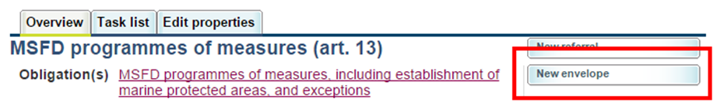

- Fill in the envelope information and press Add. Again, Denmark is used in the example:
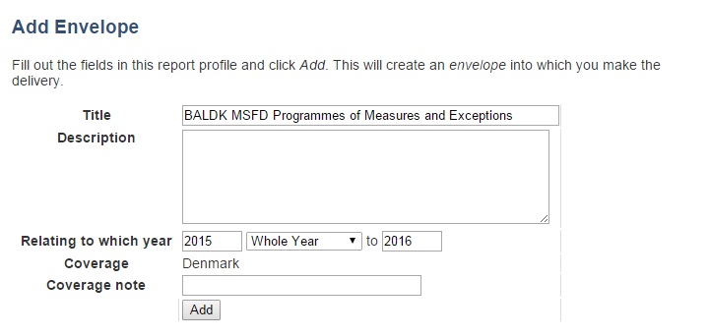

- Select the new envelope and Activate it

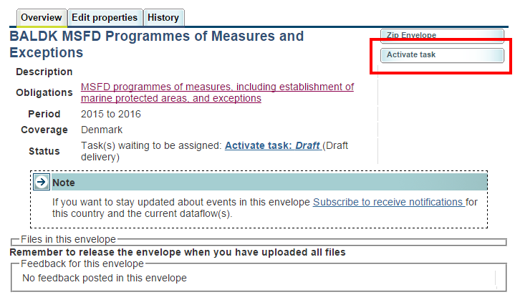

- The envelope is now active and one can open an empty measures questionnaire and an empty exceptions questionnaire.

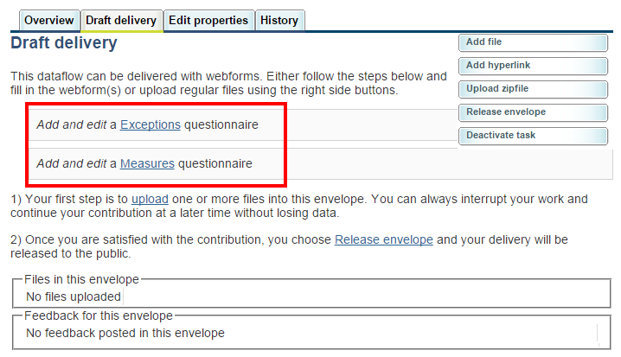

The questionnaire
The questionnaire will help you fill in either the measure.xml or the exception.xml. The questionnaire is more or less the same for measures and exceptions. The guide is based on a measure questionnaire.
Select ‘Add and edit…’ on the Draft delivery page to start the questionnaire. See bullet point 6 in the previous section.
The figure shows the questionnaire. It uses a tabular layout where the left column shows the questions, the middle column contains the answers and the right column shows some guidance remarks.
Some questions allows multiple answers. In these cases a ‘+’ and ‘-‘ button is shown next to the answer. Use these buttons to add or remove additional answers.
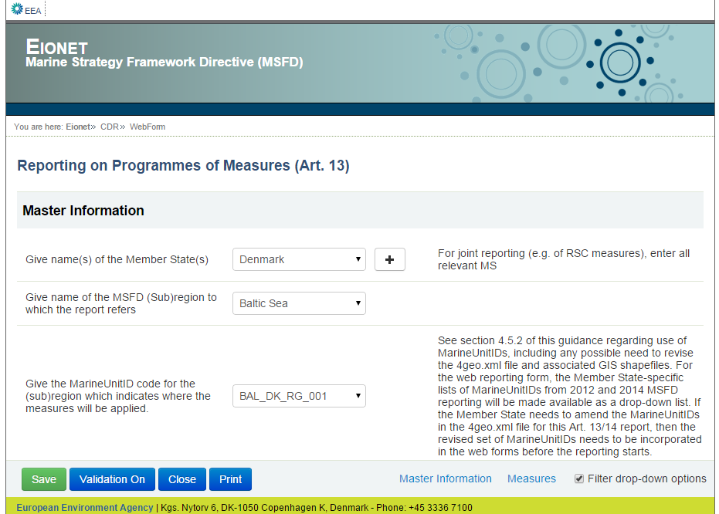

Scrolling down the questionnaire will take you to the Measure section. This section is called Exceptions in the Exceptions questionnaire.
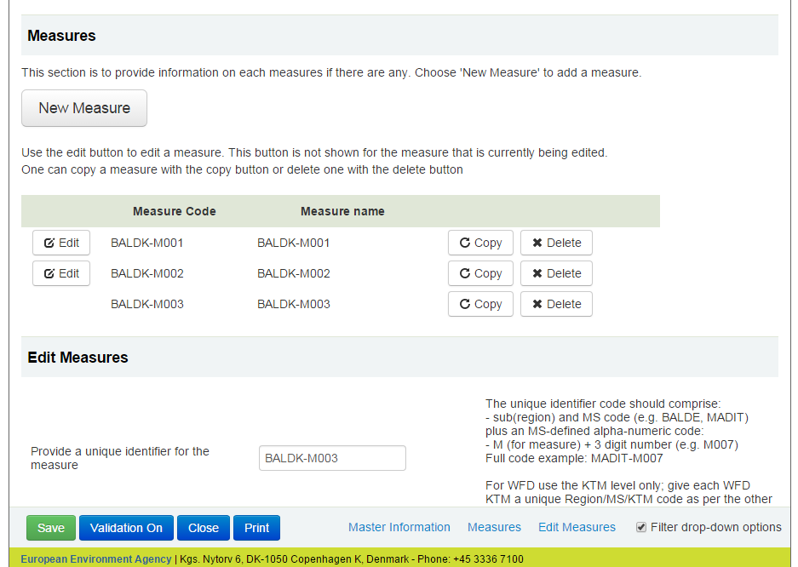
In the Measures section there is a list of all the measures that is included in the report. One can use the edit button to view and edit a measure. The row without the edit button is currently shown in the Edit Measures section. The copy button will add a copy of the measure to the end of the list. Delete will remove the measure.
One can also use the ‘New Measure’ button to add an empty measure. The ‘New Measure’ and a ‘Copy Measure’ button is available below the ‘Edit Measures’ section.

Controls
The bottom of the browser window contains a series of controls.
- ‘Save’ will save the answers in measure.xml and run a validation check. A dialog box will prompt you with a success/failure message.
- ‘Validation On/Off’ toggles validation on or off. The validation is automatically turned on after saving.
- ‘Close’ will close the questionnaire and bring you back to the envelope.
- ‘Print’ will open a new tab in your browser with a report of the answers.
On the right side, there is a ‘Filter drop-down options’ checkbox. This option influences the content of the dropdown list for regions, marine unit ID’s and environmental targets. For example, when the filter is on the region drop down list only shows regions that the current member state reported for in the article 10 reporting. Turning the filter off will show all available regions.

Name file and copying for a different (sub) region
This section will focus on how to rename the measure.xml and exception.xml. It also explains how to make a copy of the xml file and use it for a different (sub) region.

File naming
After filling in the xml file through the webform, one should rename the file according to the recommended file name pattern: Region, Country, Measures or Exceptions and a date stamp (YYYYMMDD). For example BALDK_Measures_20150615.xml

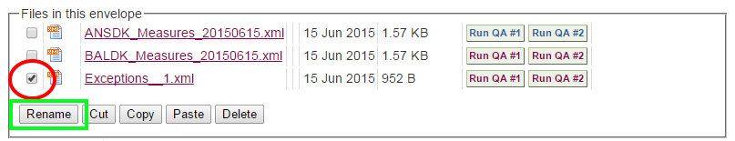

Multiple regions
It is possible to complete a (sub) report for one region, copy the xml file and update the copy for a different region or subregion.

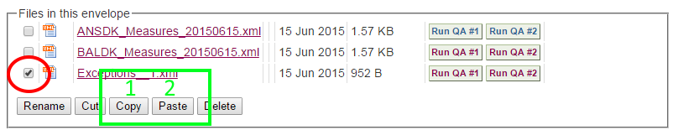

Select the file you would like to copy. Red circle.
Press Copy and then Paste to make a copy of the selected file.

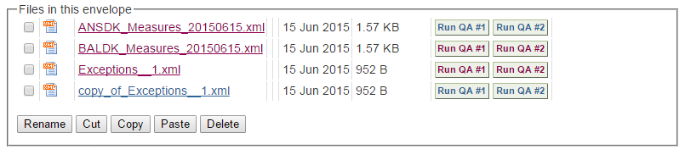

Rename the file and open it in the webform to edit the contents.

Change the region. The webform will automatically update the region part of the Measure code and Exception code when the region is changed. The measures and exceptions references environmental targets that is linked to a specific region. When the region is changed, the webform will attempt to match the environmental targets from the two regions and update them. Validation errors occur when the target matching fails.

Finalize the reporting

- After completing the questionnaires and renaming the files, the envelope view look somewhat like this:
- 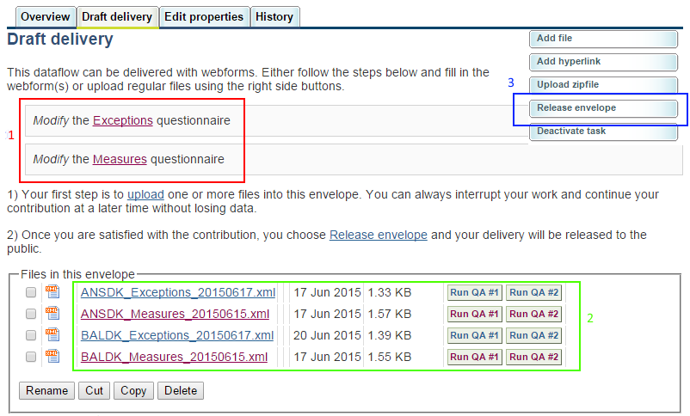

Red box no. 1: One can reopen and modify the questionnaires.
Green box no. 2: Use the ‘Run QA’ buttons to run the QA scripts on the xml files.
Blue box no. 3: Use ‘Release the envelope’ when you have finished the questionnaires and the QA’s have run successfully.

- When the xml questionnaires are completed and QA has run successfully, release the envelope.
Eionet will re-run the QA’s and the envelope will look somewhat like this:
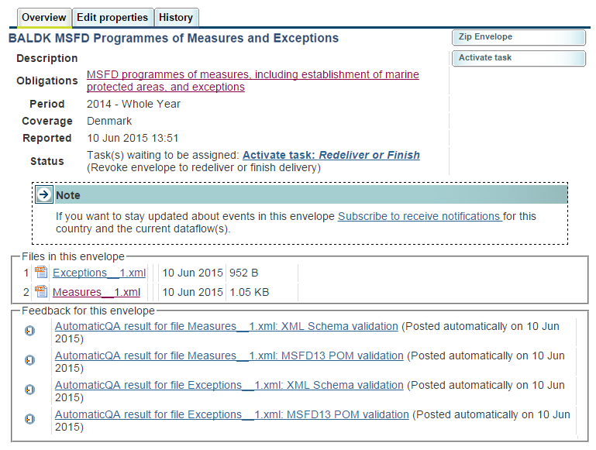

- Clicking ‘Activate task’ will bring up the ‘Finish or go back…’ tab.

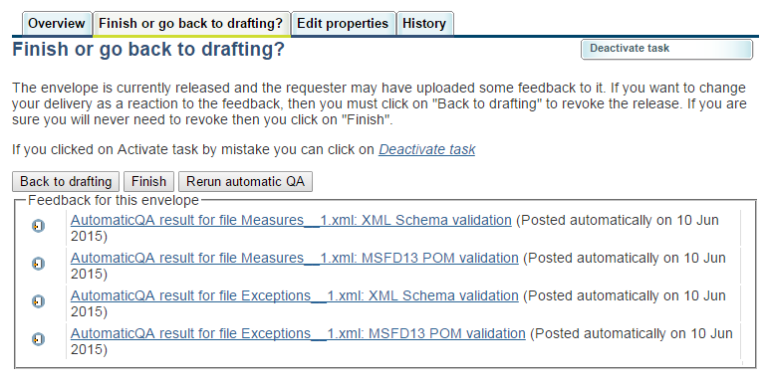
If you select ‘Back to drafting’ and ‘Activate task’ you will get back to ‘Draft delivery’ (bullet point 6) and you can continue editing the questionnaires.

Select ‘Finish’ finalizes the release of the envelope and reporting is completed.

